CORE VALUES
 | ALL-IN  We know there is no half-way in the fight against AIDS. We are all-in. We support all Vivent Health does, are staunch, proud ambassadors in all instances, are committed to our long-term success and value integrity, authenticity, credibility and professionalism.
 | ALIGNMENT  We achieve alignment of work, staff and goals through effective management, outstanding interpersonal skills and high levels of emotional intelligence. We develop our staff, value inclusion and diversity, build effective teams, listen and communicate, provide and accept feedback and criticism, and support and guide the organization to be successful.
 | ACCOUNTABILITY  We hold ourselves, our teams and our organization to the highest levels of accountability as we set and meet difficult goals. It is our responsibility to deliver and achieve the results our organization needs as we excel in our field and as leaders.
 | AGILITY  We work in a dynamic organization in which change is constant and flexibility is not optional. We value quickness and responsiveness equally with meaningful change management processes. We are strategic thinkers, comfortable and courageous in challenging the status quo and believe innovation and creativity are the surest ways to succeed.
 | ACTION-ORIENTED  We are self-directed and ambitious in pursuit of our vision and mission. Problems do not linger and opportunities are not passed up. With a deep sense of curiosity and commitment to improve, we identify issues and needs, gather information, gain support and act decisively.
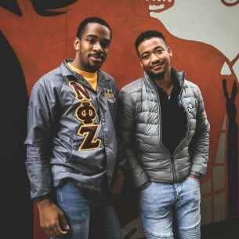 | ALLYSHIP  We value people regardless of the color of their skin, whom they love, where they live, their gender identity or how much or little money they have. We welcome, include, and learn from diverse perspectives to successfully serve our patients and clients, support our Champions, improve our communities, and advance social justice and equality.

