- Created a 5-year DEIB strategic plan | 
- Conducted ongoing training on implicit bias, micro-aggressions and related topics

- Established an Executive Leadership book and discussion club reading leading DEIB texts

 | - Achieved a majority-minority board of directors
 | - Achieved 65% of staff representing the African American, Hispanic/Latino, Asian or LGBT community
 | - Diversified the executive leadership team to within one leader of having a majority-minority team

- Established Juneteenth Day as an organizational holiday

- Completed annual, monthlong recognition and celebration of Black History Month and Pride Month

- Initiated a diversity speaker series presented for staff including Angela Davis, Bakari Sellers, Symone Sanders, and Cleve Jones among dozens of speakers

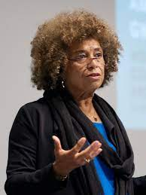 | 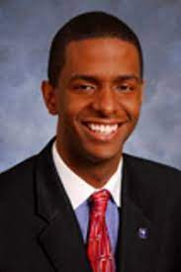 | 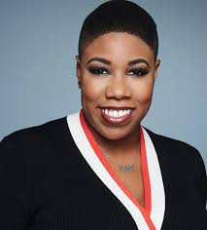 |  | 

- Served as an active member of CEO Action for Diversity & Inclusion

- Established a CEO Action Racial Equity Fellowship, a full time employee dedicated to educating and advocating on issues of societal and racial injustice

- Created a Racial Equity Scholarships at two Historically Black Colleges and Universities

 | 

- Created of LGBT Equity Scholarships at two public universities

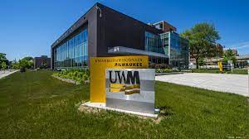 | 

- Conducted active thought leadership on LinkedIn on issues of racial and social justice

- Invested more than $500,000 in minority community-based organizations to expand access to prevention, care and treatment services

- Invested organizational funds in black owned banks across the country

